**STATED THIS 1ST JULY 2023**

BETWEEN

**WAN SHARIHA BT WAN BAHAROM (NRIC NO: 750818-02-6278).…… LANDLORD**

**AND**

**MOHAMAD NAZRI BIN SAMAON (NRIC NO: 961004-01-5203) TENANT**

**PREMISES ADDRESS:**

**B1-06-09, JALAN PERSIARAN SENIBONG BANDAR BARU BAYU SENIBONG**

**81750 MASAI JOHOR**

TENANCY AGREEMENT

**THIS TENANCY AGREEMENT** is made on this 1ST JULY 2023.

**BETWEEN** : The party whose particulars are as stated in Part I of the FIRST Schedule Hereto (Hereinafter caller "The Landlord") of the one part.

**AND** : The party whose particulars are as stated in Part II of the FIRST Schedule Hereto (hereinafter caller "The Tenant") of the one part.

**WHEREAS** the Landlord is the registered proprietor and/or beneficial owner of the property more particularly referred to and described in Part III of the Schedule ( hereinafter referred to as "the Demised Premises").

**AND WHEREAS** the Landlord is desirous of renting out the Demised Premises and the Tenant is desirous of taking on rent the said Demised Premises upon the term and conditions herein after set forth.

NOW IT HEREBY AGREED as follows:-

1. The Landlord lets and the Tenant takes the Demised Premises for the term stipulated in Part IV of the Schedule at the rent stipulated in Part V of the Schedule and subject to the terms and conditions hereinafter contained.
2. The Tenant shall upon execution of this Agreement pay the Landlord the sum stipulated in Part VI of the Schedule by way of deposit as security for the due observance and performance by the Tenant of the term and conditions of this Agreement. The said sum shall be maintained at this figure and not deemed or treated as payment of rent.
3. The Tenant hereby covenants with the Landlord as follows:-
   1. To pay the rent hereby reserved on the days and in the manner aforesaid.
   2. To pay the Landlord upon the execution of this Agreement the sum of Ringgit as specified in Part VII of the Schedule only as deposit for electricity and water charges to be incurred during the tenancy of the Demised Premises. The said sum less as may then be payable by the Tenant under

this Agreement shall be refused without interest to the Tenant on the termination of this Tenancy.

* 1. To keep the Demised Premises, the flooring and interior plaster or other surface material or rendering on walls and ceilings and the Landlords fixtures thereon including doors, windows, glass shutters, lock fastenings, electric wires, installations and fitting for the light and power and other fixtures and additional therein in good and tenantable repair and clean condition and to replace or clean condition and replace or repair any part of the Demised Premises and the Landlord's fixtures and fittings therein which shall be broken or damage due to malicious, negligent or careless acts or omission of the Tenant his servants, agents, invitees or otherwise and further that if any damage is caused to the Landlord or to any person whomsoever directly or indirectly through the said damaged condition of any part of the interior of the Demised Premises (including floorings, walls, ceilings, doors, windows and other landlord's fixtures) the Tenant shall be wholly responsible therefore and shall fully indemnify the Landlord against all claims, demands, actions and legal proceeding whatsoever made upon the Landlord by any person in respect thereof.
  2. To permit the landlord and the landlord's servants, agents and workmen and with all necessary equipment and appliances at all reasonable time after prior notice to the Tenant to enter upon the Demised Premises and to view the condition thereof and to do such works and things as may be required for any repairs, alterations or to any other part or parts of the said building and forthwith to repair and amend in a proper and workman like manner any defect for which the Tenant is liable and of which written notice shall be given to the Tenant or left in the Demised Premises and to pay the costs of the Landlord's surveyor or otherwise in respect of the preparation of the notice.
  3. Not to do or permit to be done upon the Demised Premises anything which in the opinion of the Landlord may constitute nuisance.
  4. To use the Demised Premises only for the purpose specified in Part VIII of the Schedule.
  5. Forthwith to notify the Landlord in writing of any notices served by any competent authority and with all due speed to comply with the term of the said notice as are effective and to keep the Landlord indemnified from and against all actions, costs, claims, demands and liability in respect thereof.
  6. Not to make or permit to be made any alteration or addition or partition to the Demised Premises or to the Landlord's fixtures, fittings and decoration therein without having first obtained the written consent of the Landlord therefore and upon the determination of the term hereby created, if so requested by the Landlord, to restore the Demised Premises to its original state and condition at the expense of the Tenant.
  7. Not to assign, underlet, sublet or part with the actual or legal possession or the use of the Demised Premises for any term whatsoever without the previous consent in writing of the Landlord first obtained.
  8. Tenant shall not bring or store or permit or suffer to be brought or stored on the Demised Premises or any part of the Building arms ammunition or goods, gunpowder, sulphate or any goods which are of noxious or dangerous.
  9. Not without the previous consent of the Landlord to affix, paint or otherwise exhibit on the exterior of the Demised Premises or the windows thereof or any part thereof or any name plate, signboard, placard, poster or advertisement of any flagstaff or other thing whatsoever or use the outer wall of the Demised Premises for the purpose of any public announcement or to exhibit anywhere outside the Demised Premises any indication of business or otherwise except upon the written consent of the Landlord.
  10. Not to do or permit or suffer to be done anything whereby the policy or policies of insurance on the Demised Premises against damage by fire may become void or voidable or whereby the premiums thereon may be increased and to make good all damage suffered by the Landlord and to repay to the Landlord on demand all sums paid by them by way of increased

premium and all expenses incurred by the landlord in or about any renewal of such policy or policies rendered necessary by a breach or non- observance of this covenant without prejudice to the other rights of the landlord.

* 1. Not to install or caused to be installed in the said Demised Premises any heavy equipment or electrical appliances consuming high voltage without the prior written consent of the Landlord first had and obtained.
  2. At the expiration or sooner determination of the tenancy to yield upon peaceably the Demised Premises with the fixtures, fittings and decorations thereto (Other that the Tenant's fixtures) in a tenantable repair and condition, fair wear and tear expected.

The tenant shall be responsible for all repairs and routine maintenance (including plumbing, water filter replacement, lighting/bulbs etc)

This clause shall not be enforced during the first 30 days of the commencement if tenancy.

* 1. At all times during the term hereby created to comply with all such requirements as may be imposed on the Tenant by any ordinance or Act of Parliament now or hereafter in force and any orders, rules, regulations, requirements and notices and notices there under.
  2. To bear the cost of electricity, water, sewerage mains (Indah Water) and telephone (if any) should be made payable direct to Tenaga Nasional Berhad, Jabatan Air, TM Point, Post office outlets, any local bank counter or relevant authority.
  3. Shall not nail, screw, drill, glue and paste any items or things on the wall. Any damages or loss relating the wall the Tenant shall be bear the cost of the damages, replacement or repair.

1. The Landlord hereby covenants with the Tenant as follows:-
   1. To pay the quit rent, the assessment and the maintenance fee imposed on and payable in respect of the Demised Premises.
   2. At all times throughout the tenancy to insure and keep insured the Demised Premises but excluding the Tenant's fixtures fittings and chattels from loss or damage by fire and to pay all premiums necessary for that purpose.
   3. To permit the Tenant if he punctually pays the rent hereby reserved and other charges and observes the stipulation on his part herein contained to peaceful enjoy the Demised Premises without any interruption or disturbance by the Landlord or those lawfully claiming title under or in trust for therm.
2. Provide always and it is hereby expressly agreed as follows:-
   1. if the rent hereby reserved or any part thereof shall at any time be unpaid for seven (7) days after the same shall have become due (whether formally demanded for or not) or any covenant on the Tenant's part herein contained shall not be performed or observed or if the Tenant shall have a receiving order made against him or shall have made any assignment for the benefit of his creditors or enter into any agreement or made any arrangement with his creditors by composition or otherwise or suffered any distress or attachment or execution to be levied against his good or if the Tenant for the time being shall be a company and shall go into liquidation whether compulsory or otherwise except for the purpose of reconstruction amalgamation then and in any such case it shall be lawful for the Landlord at any time thereafter to re-enter upon the Demised Premises or any part thereof in the name of the whole and thereupon the tenancy shall absolutely determine but without prejudice to the right of action of the Landlord in respect of any antecedent breach of the condition on the part of the Tenant herein contained.
   2. If the Demised Premises or any part thereof shall be destroyed or damaged by fire (except where such fire has been caused by the fault or negligence of the Tenant) so as to be unfit for human habitation or use, then the rent hereby covenanted to be paid or a fair proportion thereof according to the nature and extent of the damage sustained shall be suspended until the Premises shall again be rendered fit for habitation and use and always that

nothing in this clause shall render it obligatory on the Landlord to restate or rebuild the Demised Premises or and part thereof if the Landlord in this absolute discretion does not desire to do so in which even the Landlord shall be entitled to terminate this tenancy by two (2) months notice in writing to the Tenant and upon such termination neither party shall have any claim against the other save and except in respect of any antecedent breach.

* 1. The Landlord shall at the written request of the Tenant made not less than two (2) month before the expiration of the hereby created and if there shall not at time of such request by any existing breach or non-observance of any of the covenants of the part of the Tenant herein to be performed at the Tenant's expense grant to the Tenant tenancy or the Demised Premises for a further term and subject to the condition stipulated in Part IX of the Schedule.

1. Any notice or other document or writing required to be served delivered or given hereunder shall be sufficiently served if left addressed to the Tenant on the Demised Premises or sent to the Tenant by registered post addressed to the Tenant's last known address in Malaysia and any notice document or writing to the Landlord shall be sufficiently served if sent by registered post to the Landlord's last known address.
2. The cost of and incidental to the preparation and completion of this Agreement including stamp duty shall be paid by the Tenant.
3. The Schedule shall be taken, read and construed as part of this Agreement.
4. Time wherever mention shall be the essence of the Agreement.
5. This Agreement shall be binding upon the successor - in - title and assigns personal representative and heirs of the Landlord and the Tenant.
6. In the event the Landlord's wish to sell the demised premise than sale shall be subject to this Tenancy.
7. In the event that the tenant fails to fulfill the tenancy period, the deposit sum shall be forfeited by the Landlord.
8. The tenant is strictly prohibited from allowing illegal foreign workers with no valid work permit to reside in the demised premises.

All the home application damage or loss, tenant should restore the status quote compensation for economic losses except fair wear & tear usage. The listing for the home application at

**List of Inventories:**

# SCHEDULES

(Which is to be taken read and construed as an essential part of this Agreement)

|  |  |  |
| --- | --- | --- |
| 1. | : | **LANDLORD**  Name : WAN SHARIHA BT WAN BAHAROM NRIC No: 750818-02-6278 |
| 2. | : | **TENANT**  Name : MOHAMAD NAZRI BIN SAMAON NRIC No: 961004-01-5203  LOT 529B, BATU 18, KAMPUNG SUNGAI TIRAM, 81800 ULU TIRAM, JOHOR. |
| 3. | : | Demised Premises : APARTMENT  Address : B1-06-09, JALAN PERSIARAN SENIBONG, BANDAR BARU BAYU SENIBONG, 81750 MASAI, JOHOR. |
| 4. | : | Term :  One (1) year commencing 1ST JULY 2023 and expiring 30TH JUNE 2024. Option to renew One (1) year effective from 1ST JULY 2024 to 30TH JUNE 2025. |
| 5. | : | Monthly Rental : RM 900.00 (Ringgit Malaysia : NINE HUNDRED ONLY) |
| 6. | : | One month Refundable Security Deposit : RM 900.00 (Ringgit Malaysia : NINE HUNDRED ONLY)  Deposit cannot be used to offset the rental  Refundable Utilities  RM 500.00 (Ringgit Malaysia: FIVE HUNDRED ONLY) |
| 7. | : | Use of Demised Premises :  **Strictly for RESIDENTIAL purpose only.** |
| 8. | : | Option :  One (1) year at prevailing market rate at the time of the renewal or as the landlord and the Tenant mutually agreed thereon. |
| 9. | : | Time of Payment : Rental pay on the 1st of every month  If late payment over 7 days after Agreement date, Landlord have the right to stop the Agreement.  1 month security deposit will be forfeited and to move out immediately. |
| 10. | : | Payment Mode : **BANK ISLAM**  Account No: **12038025598829**  Bank Holder : **WAN SHARIHA BT WAN BAHAROM** |

# THE REMAINING PAGE HAS BEEN INTENTIONALLY LEFT BLANK

I hereby acknowledge receipt of access card of the above property on

# Meter Reading:

Electric Water

Owner need to pay 1 month penalty plus return 1 month deposit to tenant. If owner break the contract (before the agreement complete),

tenant can only get the deposit back when the contract finishes & no damage done to the house and no debt in utility bills.

Tenant need to pay monthly rental / water bills (SAJ) / electric bills (TNB). Monthly maintenance fee will be paid by the landlord.

To keep the demised premises and all the landlord’s installations, fixtures and fittings,

therein in good and tenantable condition and proper working orders.

Special condition

1. Strictly for residential purpose only, not for homestay business and sub-let is not allowed.

**IN WITNESS WHERE OF** the parties here to have set their hands the day and year first above written.

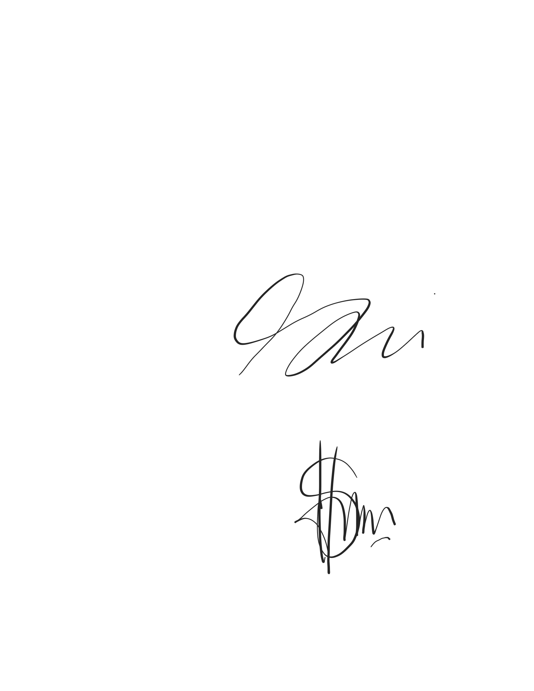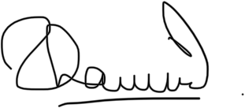

SIGNED by

The Landlord

NAME : WAN SHARIHA BT WAN BAHAROM NRIC No : 750818-02-6278

SIGNED by

The Tenant

NAME : MOHAMAD NAZRI BIN SAMAON NRIC No : 961004-01-5203

SIGNED by

The Witness

NAME: SHAMSULBAHARI BIN ABDUL MAJID NRIC No : 700304-05-5009

